Motivators
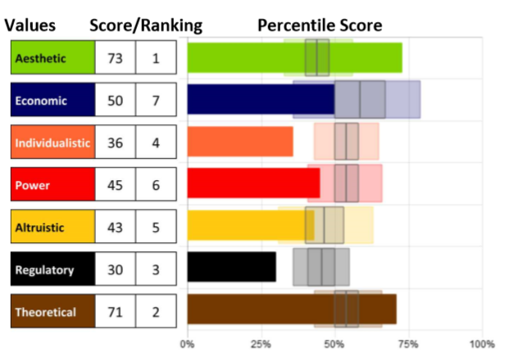
Understanding what motivates us,
what inspires us, and what we
deem important is a vital first step
in self-awareness and improving
human performance and
effectiveness. Knowing our specific
level of motivation can be crucial to
helping us understand what drives
our beliefs and actions so we can
bring them into alignment.

What are Motivators?
- The Motivators filter and guide decisions uniquely for each person, influencing individual priorities and decision-making.
- Motivators will help you understand your unique beliefs providing a clear course on how to maximize performance by achieving better alignment and passion for what you do.
- Motivators provides insight into what we want and what we believe to be true, important, or fundamental based on our formative years and our learning experiences.
- What we believe influences how we behave so the motivators can help us understand why we do what we do.

What are the 7 Motivators?
There are seven dimensions of motivation the filter and guide our
behaviors and decisions. It is vital to remember that although we can
explore each motivation individually, they cannot be separated. They
can be distinguished; however, all motivators integrate to
influence us.
- Aesthetic - drive for balance, harmony and form
- Economic - drive for a return on investment
- Individualistic - drive to stand out as independent and unique
- Power - drive to be in control or have influence
- Altruistic - drive to help others at the expense of self
- Regulatory - drive to establish order, routine and structure
- Theoretical - drive for knowledge, learning and understanding

There are many benefits of learning what Motivators
influence us.
- Our Motivators combine distinctively for each person to reveal our priorities and guide our decision-making.
- It is vital for optimal performance that our motivations are satisfied by what we do. They drive our passions, reduce fatigue, and inspire us.
- Behavior (how we act) is determined by emotion (how we feel). Motivators are the reason(s) that drive us to want to act in a particular way.
- While it’s important to explore each motivator, it is critical to remember that they cannot be separated. They can be distinguished, but all combine to create influence over our decisions.
- Those who understand their natural motivators better are far more likely to pursue the right opportunities, for the right reasons, and get the results they desire.

Why is it important to know what motivates us?
People see the world differently; we all have our own biases and
perspectives. We all have our own desires, and we all express those
views and desires through our actions. Motivators reveal our viewpoint,
our mindset, our paradigm of thought, and our way of judging and
valuing life. They are the reasons that drive us to WANT to act. We all
have different influences that drive us, and understanding ourselves
and recognizing those things that are important to others can lead to
greater understanding of one another and strengthen our relationships.

Spend some time really looking at your own motivations, and talking
with others about their priorities and perspectives with a genuine desire
to learn more about them. Listen, ask thoughtful questions, and see if
you can learn something new or different about someone you interact
with frequently. Focus on appreciating a mindset that is different than
your own, and acknowledge the value of that perspective (even if you
don’t agree).

Assessments 24x7 LLC 5927 Balfour Court, Ste. 103 Carlsbad, California 92008 USA (206) 400-6647

